Bringing Forward God’s Tithes and Our Gifts
*Doxology # 95 Praise God from whom all blessings flow; praise him, all Creatures here below; praise him above, ye heavenly host; praise Father, Son, and Holy Ghost. Amen.
*Prayer of Thanksgiving
Sharing of Joys and Concerns
The Lord’s Prayer

Our Father, who art in heaven, hallowed be thy name. Thy kingdom come, Thy will be done on earth as it is in heaven. Give us this day our daily bread and forgive us our trespasses, as we forgive those who trespass against us. And lead us not into temptation, but deliver us from evil. For thine is the kingdom, and the power, and the glory, forever. Amen.
*Singing Our Faith #117 “O God, Our Help in Ages Past”
*Blessing and Dismissal
*Postlude

Scatter to Serve God & Neighbor

Welcome to all! We gather to praise God for the innumerable blessings given to us and to grow deeper in the Spirit. Joyfully, let us lift our hearts to God.

DIRECTORY OF CHESTNUT HILL UNITED METHODIST CHURCH
Adam J. White | Minister
Sharon Mayhew | Director of Music
Monica Campbell | Administrative Assistant
Judy Martin | Bookkeeper
Judy Robertson  Elizabeth Nichols | Lay Leader  Missionary in Henry County


C hestnut Hill
United Methodist Church

Making disciples of Jesus Christ
for the transformation of the world.
You are welcome at Chestnut Hill UMC.

4660 Fort Avenue ~ Lynchburg, Virginia 24502
Church: 434-239-8423
Minister’s Cell: 434-944-7723, Minister’s Email: awhite@ves.org
Email: chestnuthillumc@comcast.net
On the Web at chestnuthillumc.net
Find us on Facebook: Chestnut Hill United Methodist Church

Chestnut Hill United Methodist Church

10:30 a.m. ~ March 8, 2026 ~ Third Sunday in Lent
Our ministry vision for the Virginia Annual Conference is “to be
disciples of Jesus Christ who are lifelong learners, who influence others to serve.”

Welcome! Join us in worshiping God!
Prelude
Welcome and Ministry Announcements
Welcome in the name of Christ our Lord. Please register your attendance, printing your name, address, phone, and email, on the attendance pad provided on your pew. Thank you for silencing cell phones as we gather to worship God.
Invocation
*Greeting
O Jesus, once along the road,
At Jacob's lonely well,
An outcast woman heard thee there
Thy great salvation tell.
Samaria's unnamed daughter found
Those streams unknown before,
The water-brooks of life that make
The weary thirst no more.
Today, to us, assembled here,
Thy gracious words have told
That mystery of love, revealed
Beside that well of old.
She told the tale to all she knew,
As we declare it now --
Our deep, divine, unfailing spring
Of grace and glory thou.

In spirit, Christ, we've sat with thee
Around the springing well
Of joy and life, and heard thee there
Its healing virtues tell.
That living water may we drink,
From fear and strife set free,
And like that faithful woman, seek
And find our peace in thee.
*Singing Our Faith #710 “Faith of Our Fathers”

Opening Prayer
Almighty God, you know that we have no power in ourselves to help ourselves: Keep us both outwardly in our bodies and inwardly in our souls, that we may be defended from all adversities which may happen to the body, and from all evil thoughts which may assault and hurt the soul; through Jesus Christ our Lord, who lives and reigns with you and the Holy Spirit, one God, for ever and ever. Amen.

Anthem “O How He Loves You and Me”

Greeting Friends and Neighbors

Prayer of Illumination
Enduring Presence, goal and guide, you go before and await our coming. Only our thirst compels us beyond complaint to conversation, beyond rejection to relationship. Pour your love into our hearts, that, refreshed and renewed, we may invite others to the living water given to us in Jesus Christ our Lord. Amen.

Scripture Lesson John 4:5-42
The Word of God for the people of God.

Thanks be to God.
Singing Our Faith #184 “Of the Father’s Love Begotten”
The Good News “All is Well that Ends Well”

**Calendar **
Monday, 3/9 | 7:00 p.m. | Wesleyan Group @ Jessen Home
Tuesday, 3/10 | 7:00 p.m. | Homeschool Game Night
Wednesday, 3/11 | 1:00 p.m. | Homeschool Play Rehearsal
Thursday, 3/12 | 9:30 a.m. | Homeschool Apiary Presentation
Friday, 3/13 | 9:30 a.m. | Homeschool
Saturday, 3/14 | 6:00 p.m. | Homeschool Teen Formal Dance
**Looking Ahead on the Calendar **
Wednesday, 3/18 | 10:30 a.m. | Merry Martha’s Circle  Prayer & Self Denial program. Followed by lunch at Charley’s.
Sunday, 3/22 | 10:00 a.m. | Choir
Friday, 3/27 |  | Deadline for newsletter articles (2nd Quarter, April-May-June).

Birthdays Coming Up: (March) 11-Bryan Tiller

For the Grocery Cart:
March ~ Canned Chunky Soups & Canned Vegetables (Pull tops)

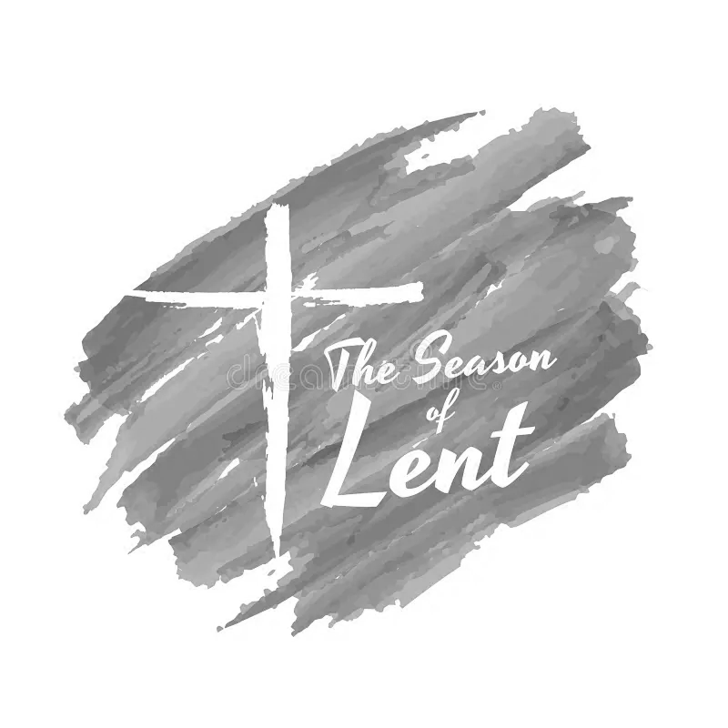

**Calendar **
Monday, 3/9 | 7:00 p.m. | Wesleyan Group @ Jessen Home
Tuesday, 3/10 | 7:00 p.m. | Homeschool Game Night
Wednesday, 3/11 | 1:00 p.m. | Homeschool Play Rehearsal
Thursday, 3/12 | 9:30 a.m. | Homeschool Apiary Presentation
Friday, 3/13 | 9:30 a.m. | Homeschool
Saturday, 3/14 | 6:00 p.m. | Homeschool Teen Formal Dance
**Looking Ahead on the Calendar **
Wednesday, 3/18 | 10:30 a.m. | Merry Martha’s Circle  Prayer & Self Denial program. Followed by lunch at Charley’s.
Sunday, 3/22 | 10:00 a.m. | Choir
Friday, 3/27 |  | Deadline for newsletter articles (2nd Quarter, April-May-June).
Birthdays Coming Up: (March) 11-Bryan Tiller

For the Grocery Cart:
March ~ Canned Chunky Soups & Canned Vegetables (Pull tops)

